GANADO INDEPENDENT SCHOOL DISTRICT
SPECIAL EDUCATION OPERATING PROCEDURES

Ganado ISD has entered into an Interlocal Agreement to cooperatively operate its special education programs under the authority of Tex. Ed. Code § 11.157. The Jackson County Special Services Cooperative may provide for the efficient delivery of legally required special education and related services to Ganado ISD’s eligible students with disabilities as set forth in the Interlocal Agreement, including the implementation of these Special Education Operating Procedures.

2.14 EVALUATIONS SUPPLEMENT—AREAS OF ELIGIBILITY
AUTISM
DEAF-BLINDNESS
DEAF OR HARD OF HEARING
EMOTIONAL DISTURBANCE
INTELLECTUAL DISABILITY
MULTIPLE DISABILITIES
ORTHOPEDIC IMPAIRMENT
OTHER HEALTH IMPAIRMENT
SPECIFIC LEARNING DISABILITY
SPEECH OR LANGUAGE IMPAIRMENT
TRAUMATIC BRAIN INJURY
VISUAL IMPAIRMENT
NONCATEGORICAL EARLY CHILDHOOD
FOR MORE INFORMATION ABOUT EACH AREA OF ELIGIBILITY

Ganado ISD Board Policy along with these Special Education Operating Procedures constitute the Policies and Procedures of Ganado ISD, designed to be consistent with the State policies and procedures developed pursuant to the IDEA. Ganado ISD Special Education Operating Procedures are not to be for the purpose of creating a requirement that is not otherwise imposed by the Individuals with Disabilities Education Improvement Act (“IDEA”), together with its implementing federal regulations, state statutes and rules, as they shall from time to time be amended, and shall not be construed to create a higher standard than that established by IDEA. These Special Education Operating Procedures will be posted on Ganado ISD’s website. These Special Education Operating Procedures should be interpreted consistent with the IDEA. Ganado ISD’s Special Education Operating Procedures are reviewed and updated, as needed, on at least an annual basis. Ganado ISD will make timely changes to policies and procedures in response to IDEA amendments, regulatory or rule changes, changes to state policy, or new legal interpretation as are necessary to bring Ganado ISD into compliance with the requirements of IDEA. Ganado ISD maintains systems to ensure that all students with disabilities residing in the District, including students with disabilities attending non-public schools, regardless of the severity of their disabilities, and who are in need of special education and related services, are identified, located, and evaluated and provided a free appropriate public education. Ganado ISD maintains systems to ensure that students with disabilities and their parents are afforded the procedural safeguards required under the IDEA (and its implementing federal regulations, state statutes and rules) including with respect to the confidentiality of records and personally identifiable information.

AUTISM
Students with autism typically have a developmental disability significantly impacting verbal and nonverbal communication and social interaction which adversely affects a student’s educational performance. This delay generally manifests prior to the age 3.
A student may not be determined eligible as a student with autism if the student’s educational performance is adversely affected primarily because the student has an emotional disturbance.
The written evaluation report by the group of qualified professionals must include specific recommendations for behavioral interventions and strategies.
Additional characteristics associated with autism may include—
- engagement in repetitive activities and stereotyped movements;
- resistance to environmental change or change in daily routines; and/or
- unusual responses to sensory experiences.
A student who manifests the characteristics of autism after age 3 could be identified as having autism if the criteria in this section are identified.
The definitions of conditions or categories that are used for purposes of establishing an individual's eligibility for mental health services, as found in the Diagnostic and Statistical Manual of Mental Disorders (DSM), are not synonymous with criteria used for determining whether a child is a “child with a disability” for purposes of establishing eligibility for services under the IDEA. The group of qualified professionals conducting an evaluation of a student suspected of having autism will conduct assessments and observations, and collect data, as necessary for the ARD Committee to make an eligibility determination.
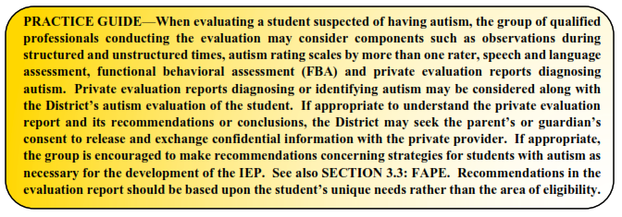

DEAF-BLINDNESS
A student who may be eligible under the category of deaf-blindness must have concurrent or coexistent hearing and visual impairments. Additionally, the combination of these impairments must cause such severe communication and other developmental and educational needs that the eligible student cannot be accommodated in a special education program solely for children with deafness or children with blindness.
A student with deaf-blindness is one who, based on an evaluation conducted in accordance with the procedures outlined in SECTION 2.0: EVALUATIONS, meets—
- the eligibility criteria for deaf or hard of hearing and visual impairment;
- the eligibility criteria for a student with a visual impairment and has a suspected hearing loss that cannot be demonstrated conclusively, but a speech/language therapist, a certified speech and language therapist, or a licensed speech language pathologist indicates there is no speech at an age when speech would normally be expected;
A student with deaf-blindness is also one who, based on an evaluation conducted in accordance with the procedures outlined in SECTION 2.0: EVALUATIONS, has—
- documented hearing and visual losses that, if considered individually, may not meet the requirements for deaf or hard of hearing or visual impairment, but the combination of such hearing and visual losses adversely affects the student's educational performance; or
- a documented medical diagnosis of a progressive medical condition that will result in concomitant hearing and visual losses that, without special education intervention, will adversely affect the student's educational performance.
The group of qualified professionals conducting an evaluation of a student suspected of having deaf-blindness will conduct assessments and observations, and collect data, as necessary for the ARD Committee to make an eligibility determination.

DEAF OR HARD OF HEARING
A student may be eligible for special education and related services as a student who is deaf or hard of hearing if the hearing impairment is so severe that it impairs the processing of linguistic information through hearing with or without amplification, and that adversely affects educational performance.
The group of qualified professionals must ensure that the evaluation data includes—
- An otological examination performed by an otolaryngologist or by a licensed medical doctor, with documentation that an otolaryngologist is not reasonably available, and an audiological evaluation performed by a licensed audiologist, and
- a description of the implications of the hearing loss for the student's hearing in a variety of circumstances with or without recommended amplification.
The group of qualified professionals conducting an evaluation of a student suspected of being deaf or hard of hearing will conduct assessments and observations, and collect data, as necessary for the ARD Committee to make an eligibility determination. The group should consider the student’s unique mode of communication when conducting the evaluation.
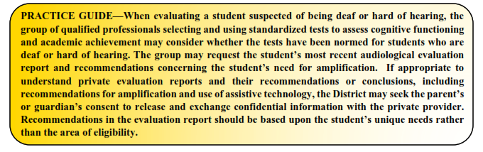

EMOTIONAL DISTURBANCE
A student may be eligible for special education and related services as a student with an emotional disturbance if the student exhibits one or more of the following characteristics over a long period of time and to a marked degree that adversely affects educational performance:
- an inability to learn, which cannot be explained by intellectual, sensory, or health factors;
- an inability to build or maintain satisfactory interpersonal relationships with peers and teachers;
- inappropriate types of behavior or feelings under normal circumstances;
- a general pervasive mood of unhappiness or depression; or
- a tendency to develop fears or physical symptoms associated with personal or school problems.
The term "emotional disturbance" also includes students with schizophrenia. The term does not include a student who is socially maladjusted unless the ARD Committee determines based on evaluation by a group of qualified professionals that the student has an emotional disturbance consistent with the criteria outlined above. The term “social maladjustment” is a persistent pattern of violating social norms with truancy, substance abuse, perpetual struggle with authority or manipulation.
With respect to the criterion that the student manifest one or more characteristics of emotional disturbance to a “marked degree,” this generally refers to the frequency, duration, or intensity of a student’s emotionally disturbed behavior in comparison to the behavior of peers and can be indicative of either degree or acuity or pervasiveness.
The definitions of conditions or categories that are used for purposes of establishing an individual's eligibility for mental health services, as found in the Diagnostic and Statistical Manual of Mental Disorders (DSM), are not synonymous with criteria used for determining whether a child is a “child with a disability” for purposes of establishing eligibility for services under the IDEA. IDEA neither requires nor precludes the application of the DSM criteria in making eligibility determinations. The DSM classification system may assist the group of qualified professionals in evaluating and diagnosing disability conditions in students, including the disability condition of emotional disturbance.
The group of qualified professionals conducting an evaluation of a student suspected of having an emotional disturbance will conduct assessments and observations, and collect data, as necessary for the ARD Committee to make an eligibility determination.
The group of qualified professionals must ensure that the written evaluation report includes specific recommendations for behavioral supports and interventions.

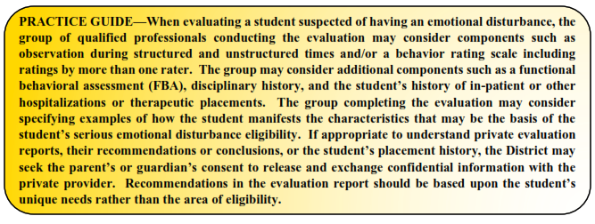

INTELLECTUAL DISABILITY
A student with an intellectual disability displays significantly sub-average general intellectual functioning, coexisting with deficits in adaptive behavior, that adversely affects the student’s educational performance. The student’s sub-average general intellectual functioning and coexistent deficits in adaptive behavior typically manifest during the student’s developmental period.
A student with an intellectual disability is one who:
- has been determined to have significantly sub-average intellectual functioning as measured by a standardized, individually administered test of cognitive ability in which the overall test score is at least two standard deviations below the mean, when taking into consideration the standard error of measurement of the test; and
- concurrently exhibits deficits in at least two of the following areas of adaptive behavior: communication, self-care, home living, social/interpersonal skills, use of community resources, self-direction, functional academic skills, work, leisure, health, or safety.
The group of qualified professionals conducting an evaluation of a student suspected of having an intellectual disability will conduct assessments and observations, and collect data, as necessary for the ARD Committee to make an eligibility determination.
It is permissible to have evaluation criteria that use intelligence tests to determine whether a child has a disability, provided that the intelligence test has been validated for the specific purpose for which it is being used, that neither the test itself nor its administration is racially or culturally discriminatory, and does not constitute the sole criterion for determining an appropriate educational program for a child.
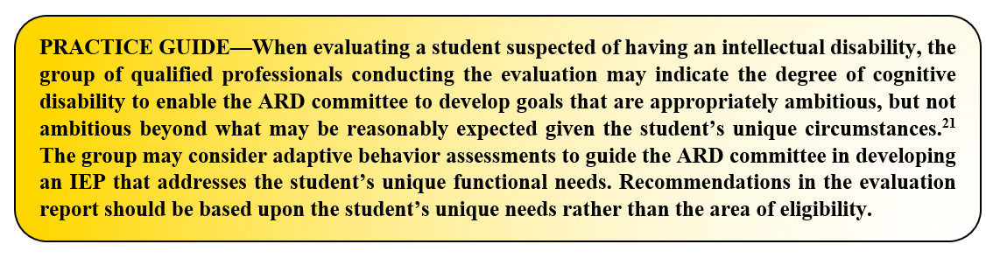
A student who may be eligible for special education and related services as a student with multiple disabilities has more than one disability or concurrent impairments (such as intellectual disability and a visual impairment or an emotional disturbance and orthopedic impairment). The combination of these disabilities results in such severe educational need that the student cannot be accommodated in special education programs designed solely for students with one of the impairments. “Multiple disabilities” does not include deaf-blindness.
To qualify as a student with multiple disabilities, the student must have a combination of disabilities and meet all of the following conditions—
- The student's disability is expected to continue indefinitely, and
- the disabilities severely impair performance in two or more of the following areas:
  - psychomotor skills
  - self-care skills
  - communication
  - social and emotional development
  - cognition.
Students who have more than one of the disabilities but who do not meet the criteria cited above must not be classified or reported as having multiple disabilities.
The group of qualified professionals conducting an evaluation of a student suspected of having multiple disabilities will conduct assessments and observations, and collect data, as necessary for the ARD Committee to make an eligibility determination.
ORTHOPEDIC IMPAIRMENT
A student with a severe orthopedic impairment adversely affecting her or his educational performance may be eligible for special education and related services. The phrase orthopedic impairment includes impairments caused by disease, like poliomyelitis or bone tuberculosis, as well as impairments from other causes, such as cerebral palsy, amputations, and fractures or burns that cause contractures.
The group of qualified professionals that collects or reviews evaluation data in connection with the determination of a student's eligibility based on an orthopedic impairment must include a licensed physician. “Medical services” under IDEA are defined as services provided by a licensed physician to determine whether a child has a medically related disabling condition, which results in the child's need for special education and related services. The District will ensure that such services are at no cost to the parent.
The group of qualified professionals conducting an evaluation of a student suspected of having an orthopedic impairment will conduct assessments and observations, and collect data, as necessary for the ARD Committee to make an eligibility determination.
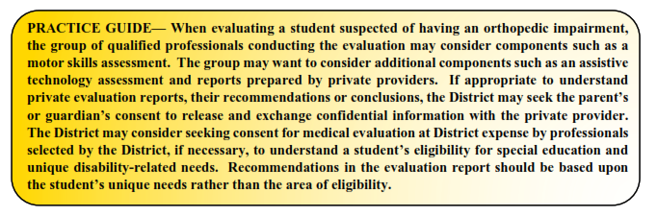

OTHER HEALTH IMPAIRMENT
A student may be eligible for special education and related services as a student with Other Health Impairment (OHI) if the student exhibits limited strength, vitality or alertness, including a heightened alertness to environmental stimuli, resulting in limited alertness in the educational environment, which is due to chronic or acute health problems, and by reason thereof demonstrates an educational need for specially designed instruction.
This disability category includes such health conditions as asthma, attention deficit disorder or attention deficit hyperactivity disorder, diabetes, epilepsy, a heart condition, hemophilia, lead poisoning, leukemia, nephritis, rheumatic fever, sickle cell anemia, and Tourette syndrome. The list of acute or chronic health conditions in the definition of OHI is not exhaustive, but rather provides examples of problems that children have that could make them eligible for special education and related services under the category of other health impairment.
The group of qualified professionals that collects or reviews evaluation data in connection with the determination of a student's eligibility based on other health impairment must include a licensed physician. “Medical services” under IDEA are defined as services provided by a licensed physician to determine whether a child has a medically related disabling condition, which results in the child's need for special education and related services. The District will ensure that such services are at no cost to the parent.
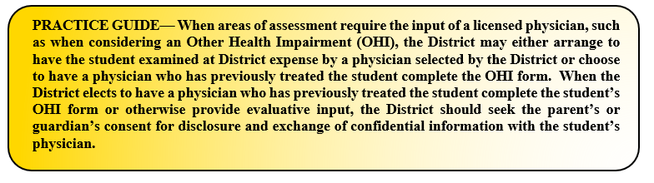
The group of qualified professionals conducting an evaluation of a student suspected of having an OHI will conduct assessments and observations, and collect data, as necessary for the ARD Committee to make an eligibility determination.

SPECIFIC LEARNING DISABILITY
See also SECTION 2.7: EVALUATIONS.
Prior to conducting an initial evaluation of a student suspected of having a specific learning disability, in order to ensure that underachievement in a student suspected of having a specific learning disability is not due to lack of appropriate instruction in reading or mathematics, the group of qualified professionals will consider the following:

- Data that demonstrates the student was provided appropriate instruction in reading and/or mathematics within general education settings delivered by qualified personnel.
- Data-based documentation of repeated assessments of achievement at reasonable intervals, reflecting formal evaluation of student progress during instruction.
  - Documentation of the repeated assessments may include RtI progress monitoring data, in-class tests on grade-level curriculum, or other regularly administered District or classroom assessments. Intervals are considered reasonable if consistent with the assessment requirements of a student's specific instructional program.

In order to qualify as a student with a specific learning disability (SLD), the student—

- has been determined through a variety of assessment tools and strategies to meet the criteria for a specific learning disability;
- does not achieve adequately for the student's age or meet state-approved grade-level standards in oral expression, listening comprehension, written expression, basic reading skill, reading fluency skills, reading comprehension, mathematics calculation, or mathematics problem solving when provided appropriate instruction, as indicated by performance on multiple measures such as in-class tests; grade average over time (e.g. six weeks, semester); norm- or criterion-referenced tests; statewide assessments; or a process based on the student's response to evidence-based intervention;
- does not make sufficient progress when provided a process based on the student's response to evidence-based intervention as indicated by the student's performance relative to the performance of the student's peers on repeated, curriculum-based assessments of achievement at reasonable intervals, reflecting student progress during classroom instruction; or
- exhibits a pattern of strengths and weaknesses in performance, achievement, or both relative to age, grade-level standards, or intellectual ability, as indicated by significant variance among specific areas of cognitive function, such as working memory and verbal comprehension, or between specific areas of cognitive function and academic achievement.

When considering a student for eligibility as a student with a specific learning disability, the group of qualified professionals will:

- use information from an observation in routine classroom instruction and monitoring of the student's performance that was done before the student was referred for an evaluation; or
- have at least one member of the group of qualified professionals conduct an observation of the student's academic performance in the regular classroom.
The group of qualified professionals conducting an evaluation of a student suspected of having a specific learning disability will conduct assessments and observations, and collect data, as necessary for the ARD Committee to make an eligibility determination.

SPEECH OR LANGUAGE IMPAIRMENT
A speech or language impairment includes communication disorders, such as stuttering, impaired articulation, expressive or receptive language impairment, or voice impairment that adversely affects a student’s educational performance.
The group of qualified professionals that collects or reviews evaluation data in connection with the determination of a student's eligibility based on a speech or language impairment must include a certified speech and hearing therapist, a certified speech and language therapist, or a licensed speech/language pathologist.
The group of qualified professionals conducting an evaluation of a student suspected of having a speech or language impairment will conduct assessments and observations, and collect data, as necessary for the ARD Committee to make an eligibility determination.

TRAUMATIC BRAIN INJURY
Students with traumatic brain injury have acquired injury to the brain caused by an external physical force, resulting in total or partial functional disability or psychosocial impairment, or both, that adversely affects educational performance. The term applies to open or closed head injuries resulting in impairments in one or more areas, such as cognition; language; memory; attention; reasoning; abstract thinking; judgment; problem-solving; sensory, perceptual, and motor abilities; psychosocial behavior; physical functions; information processing; and speech. The term does not apply to injuries that are congenital or degenerative, or to brain injuries induced by birth trauma.
The group of qualified professionals that collects or reviews evaluation data in connection with the determination of a student's eligibility based on a traumatic brain injury must include a licensed physician, in addition to—
- a licensed specialist in school psychology (LSSP)
- an educational diagnostician, or
- other appropriately certified or licensed practitioner with experience and training in the area of the disability.
“Medical services” under IDEA are defined as services provided by a licensed physician to determine whether a child has a medically related disabling condition, which results in the child's need for special education and related services. The District will ensure that such services are at no cost to the parent.
The group of qualified professionals conducting an evaluation of a student suspected of having a traumatic brain injury will conduct assessments and observations, and collect data, as necessary for the ARD Committee to make an eligibility determination.
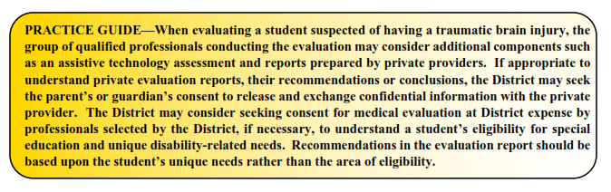
VISUAL IMPAIRMENT
A student with a visual impairment may qualify for special education and related services if the student has an impairment in vision, even with correction (such as glasses or contact lenses), that adversely affects educational performance. The phrase visual impairment includes both partial sight and blindness.
A student with a visual impairment is one who—
- has been determined by a licensed ophthalmologist or optometrist to
  - have no vision or to have a serious visual loss after correction or
  - have a progressive medical condition that will result in no vision or a serious visual loss after correction.
If the student with a visual impairment will use tactual media (which includes braille) as a primary tool for learning to be able to communicate in both reading and writing at the same level of proficiency as other students of comparable ability, the student with a visual impairment is considered to be functionally blind.
The group of qualified professionals that collects or reviews evaluation data in connection with the determination of a student's eligibility based on a visual impairment includes a person who is appropriately certified as an orientation and mobility specialist. The District must ensure that an appropriately certified orientation and mobility specialist is included in any reevaluation of a student who has been determined to be eligible for the district's special education program on the basis of a visual impairment.
The written report from the group of qualified professionals includes:
- a report by a licensed ophthalmologist or optometrist of the student’s visual loss stated in exact measures of visual field and corrected visual acuity at a distance and at close range in each eye. If exact measures cannot be obtained, the eye specialist must so state and provide best estimates. The report by the licensed ophthalmologist or optometrist should also include prognosis whenever possible.
- a functional vision evaluation by a certified teacher of students with visual impairments or a certified orientation and mobility specialist that includes the performance of tasks in a variety of environments requiring the use of both near and distance vision and recommendations concerning the need for a clinical low vision evaluation.
- a learning media assessment by a certified teacher of students with visual impairments including recommendations concerning which specific visual, tactual, and/or auditory learning media are appropriate for the student and whether or not there is a need for ongoing evaluation in this area.
- an orientation and mobility evaluation conducted by a person who is appropriately certified as an orientation and mobility specialist and must be conducted in a variety of lighting conditions and in a variety of settings, including in the student's home, school, and community and in settings unfamiliar to the student.
The group of qualified professionals conducting an evaluation of a student suspected of having a visual impairment will conduct assessments and observations, and collect data, as necessary for the ARD Committee to make an eligibility determination.

NONCATEGORICAL EARLY CHILDHOOD
Children between the ages of 3-5 who are evaluated as having an intellectual disability, an emotional disturbance, a specific learning disability or autism may be described as “noncategorical early childhood” for the purposes of special education eligibility.

The group of qualified professionals that collects or reviews evaluation data in connection with the determination of the child's eligibility based on noncategorical early childhood must include the applicable members for intellectual disability, emotional disturbance, specific learning disability, or autism. The group of qualified professionals conducting an evaluation of a student suspected of meeting eligibility criteria for a noncategorical early childhood disability will conduct assessments and observations, and collect data, as necessary for the ARD Committee to make an eligibility determination.

FOR MORE INFORMATION ABOUT EACH AREA OF ELIGIBILITY
In Texas, eligibility is determined by the student’s Admission, Review and Dismissal (ARD) committee. The phrase multidisciplinary team refers to the group of District staff tasked with using a variety of assessment tools and strategies to gather relevant functional, academic and developmental information about the student, including information provided by the parent, as part of the special education evaluation process.
- For more information about AUTISM, please contact the Special Education Director.

- For more information about DEAF-BLINDNESS, please contact the Special Education Director.

- For more information about DEAF OR HARD OF HEARING, please contact the Special Education Director.

- For more information about EMOTIONAL DISTURBANCE, please contact the Special Education Director.

- For more information about INTELLECTUAL DISABILITY, please contact the Special Education Director.

- For more information about MULTIPLE DISABILITIES, please contact the Special Education Director.

- For more information about ORTHOPEDIC IMPAIRMENT, please contact the Special Education Director.

- For more information about OTHER HEALTH IMPAIRMENT, please contact the Special Education Director.

- For more information about SPECIFIC LEARNING DISABILITY, please contact the Special Education Director.

- For more information about SPEECH OR LANGUAGE IMPAIRMENT, please contact the Special Education Director.
- For more information about TRAUMATIC BRAIN INJURY, please contact the Special Education Director.

- For more information about VISUAL IMPAIRMENT, please contact the Special Education Director.

- For more information about NONCATEGORICAL EARLY CHILDHOOD, please contact the Special Education Director.

34 C.F.R. § 300.8(c)(1)
34 C.F.R. § 300.8(c)(1)(ii)
19 TEX. ADMIN. CODE §89.1040(c)(1)
34 C.F.R. § 300.8(c)(1)(iii)
Letter to Coe (OSEP 9/14/1999)
34 CFR, § 300.8(c)(2)
19 TEX. ADMIN. CODE §89.1040(c)(2)
The terms auditory impairment, hearing impairment, and deaf or hard of hearing are referenced in Texas law and share the same meaning; federal law typically references the terms deafness and hearing impairment.
34 CFR § 300.8(c)(3)
19 TEX. ADMIN. CODE §89.1040(c)(3)
Tex. Ed. Code § 29.303
34 CFR § 300.8(c)(4)
Hansen v. Republic R-III School District, 632 F.3d 1024 (8th Cir. 2011); Springer v. Fairfax County School Board, 134 F.3d 659 (4th Cir. 1998).
Letter to Anonymous (OSEP 8/11/1989)
Letter to Coe (OSEP 9/14/1999)
Letter to Woodson (OSEP 4/5/1989)
19 TEX. ADMIN. CODE §89.1040(c)(4)
34 CFR § 300.8(c)(6)
19 TEX. ADMIN. CODE §89.1040(c)(5)
Letter to Warrington (OSEP 9/2/1993)
E.R. v. Spring Branch Independent School District, 909 F.3d 754 (5th Cir. 2018)
34 CFR § 300.8(c)(7)
19 TEX. ADMIN. CODE §89.1040(c)(6)
34 CFR § 300.8(c)(8)
19 TEX. ADMIN. CODE §89.1040(c)(7)
34 CFR § 300.34(c)(5)
Letter to Anonymous (OSEP 6/3/2020)
34 CFR § 300.8(c)(9)
Id.
71 Fed. Reg. 46550 (August 14, 2006)
Letter to Sterner (OSEP 8/19/1998)
19 TEX. ADMIN. CODE §89.1040(c)(8)
34 CFR § 300.34(c)(5)
Letter to Anonymous (OSEP 6/3/2020)
Alvin Independent School District v. A.D., 503 F.3d 378 (5th Cir. 2007)(Student was not eligible under IDEA because he had passing grades and success on state skills test evidencing academic progress; his teachers testified that, despite his behavioral issues, he did not need special education and was achieving social success in school; and many of his behavioral problems resulted from non-ADHD related issues like alcohol abuse and a death in the family).
19 TEX. ADMIN. CODE § 89.1040(c)(9)
Id.; 34 C.F.R. § 300.309
34 CFR § 300.310(b)
34 CFR § 300.310(c)(11)
19 TEX. ADMIN. CODE § 89.1040(c)(10)
34 CFR § 300.8(c)(12)
22 TEX. ADMIN. CODE § 465.38(b)(effective October 7, 2020)
19 TEX. ADMIN. CODE § 89.1040(c)(11)
34 CFR § 300.34(c)(5)
Letter to Anonymous (OSEP 6/3/2020)
34 CFR § 300.8(c)(13)
19 TEX. ADMIN. CODE § 89.1040(c)(12)(A)
19 TEX. ADMIN. CODE § 89.1040(c)(12)(B)
19 TEX. ADMIN. CODE § 89.1040(c)(12)(D)
19 TEX. ADMIN. CODE § 89.1040(c)(12)(E)
19 TEX. ADMIN. CODE § 89.1040(c)(12)(A)
19 TEX. ADMIN. CODE § 89.1040(c)(12)(A)(ii)(I)
19 TEX. ADMIN. CODE § 89.1040(c)(13)
19 TEX. ADMIN. CODE § 89.1040(b); 19 TEX. ADMIN. CODE § 89.1050(a)(5)
34 C.F.R. § 300.306

